Q1

(a)

K1:

500 0 249

0 375 249

0 0 1

K2:

500 0 251

0 375 252

0 0 1

(b)

500 0 249 0

0 375 249 0

0 0 1 0

(c)

(444, 380)

(d)

500 0 251 50.2

0 1687.5 252 125.4

0 0 1 0.2

(e)

(175, 386)

(f)

The point of intersection of the line joining the camera centres (the baseline) with the image plane.

(g)

Q2

(a)

The amount of light reflected by the surface.

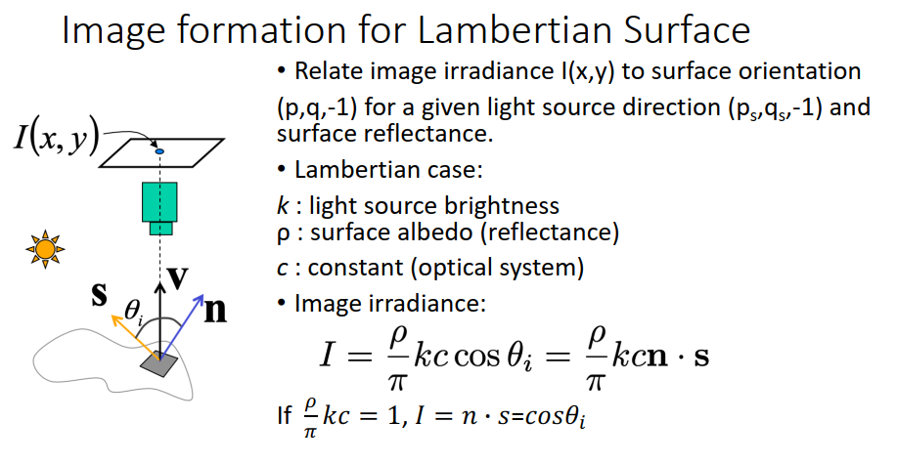

If the computed I is less than 0, then set it to 0.

(b)